**Final Project – Measurements Example**

The measurements example is a system that manages measurements taken at various geographic locations(1). Locations are grouped into areas. So, for example, there may be several locations on Mount Rainier at which measurements are made. Mount Rainier is the area, the locations are the actual places at which measurements are made.

The areas can belong to one or more categories. So, for example, Mount Hood and Mount Rainier both are in the category Volcanoes(2).

**Use Cases**

* Administrator
  + Edit category, area and location information
  + Create, delete, update
* Technician
  + Enter measurements for locations in an area
* Guest
  + Create reports
  + Overall summaries
  + Reports on selected areas or locations or categories

**Database**

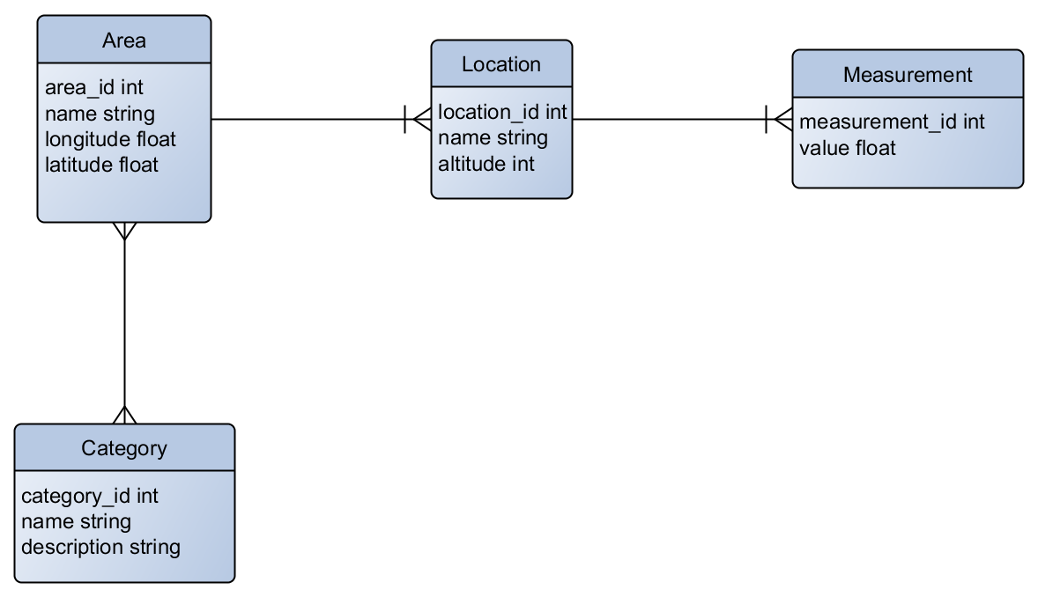

**Tables**

The entity-relation diagram for the measurements database is above.

* area
  + Integer area_id, PK
  + Name
  + Longitude and latitude
* location
  + Integer location_id, PK
  + Name
  + Altitude
* measurement
  + Integer measurement_id, PK
  + Value, decimal
  + Timestamp
* category
  + Integer category_id, PK
  + Name
  + Description
* category-area
  + Represents the many-many relationship between category and area

**Relationships**

* An area can be in 0 or more categories. A category can contain 0 or more areas.
* A measurement belongs to a single location. There may be 0 or more measurements made at each location
* A ‘location’ belongs to a single area. There may be 0 or more locations identified at a single area.

**Sample Data**

The database tables can be set up using the Python script “create_tables.py”. The script creates an SQLite database file named measures.sqlite in the current directory.

Data can be added to the tables using the Python script “add_data1.py”

You can download the file “measures.sqlite” with the tables and data already created.

==================================================================

Extra notes

1. We are not saying what the values actually represent, but they might be rainfall or temperature, for example. (If these locations were very rainy or very cold.)
2. Just the place you want to live, right?